Week 3 Notes

Boosting – XGBoost
Gboost = gradient boosting
- Gradient descending is the overall loss (error rate)
- Change in loss relative to change in set of predictions
- Calculate loss for each prediction
How big was the error and what direction need to improve
- Graditent value for every prediction compared to actual value
- Making a gradient of all predictions with their error value (loss)
  - For multiclass: each class gets a error/loss value (takes a long time)
Learning rate (0.1): very tempered correction rate, slower learning rate
- Good if lots of variation in data / outliers
MSE and LogLoss
logLoss = what is the correct class -> probability of class 1 compared to probability of other classes
compared to adaboost or rand forest
- Gradient is new target. Original targets (actual values) are only used for first round of training, sequential rounds are trained on the previous gradient
- LEARNER ZERO – dummy model
  - Every predictions gets a even weight (if 2: .5/.5, if 3: .33/.33/.33)
  - Must first predict loss to calculate gradients for sequential model
- Lerarner 1 trained on gradient – target changes every round

Limitations
- Slow training
  - Sequential
- Expensive split finding
- - histogram (binning)
- Risk of overfitting
- Sensitivity to hyperparameters
Additional features
- Correct for class imbalance (scale_pos_weight)
- Workflow for missing values
  - Handles this at splits
    - NANs work!
CatBoost – hist binning
- Symmetric (oblivious)
  - Same split on every node at the same level
    - What’s best across all the nodes – every level is a single split
- Good with high cardinality categorical variables
  - Ordered target encoding:
    - Ex: color and target
      - Color target encode
      - Red 1 0.5
      - Red 0 1.0
      - Green 1 0.5
      - Blue 0 0.5
      - Green 1 1.0
      - Green 0 0.75
    - Before it trains a single model, it recognizes permutations (changes order for encoding)
  - Great for categorical variables! Avoid one hot encoding
- Once its trained it is VERY FAST with predictions
  - Good for credit card fraud

LightGBM – hist binning
- Feature fraction
  - Subset of features by tree or node
- Supports categorical features
  - Autodetected, best to specify dtype
- How – partitioning
  - Group by category -> calculate average gradient score per category -> sort in rank order

XGBoost – hist binning
- Can handle categories
  - Change dtype to category
  - Enable
- Supports categorical features
  - Autodetected, best to specify dtype
- How – partitioning
  - Group by category -> calculate average gradient score per category -> sort in rank order

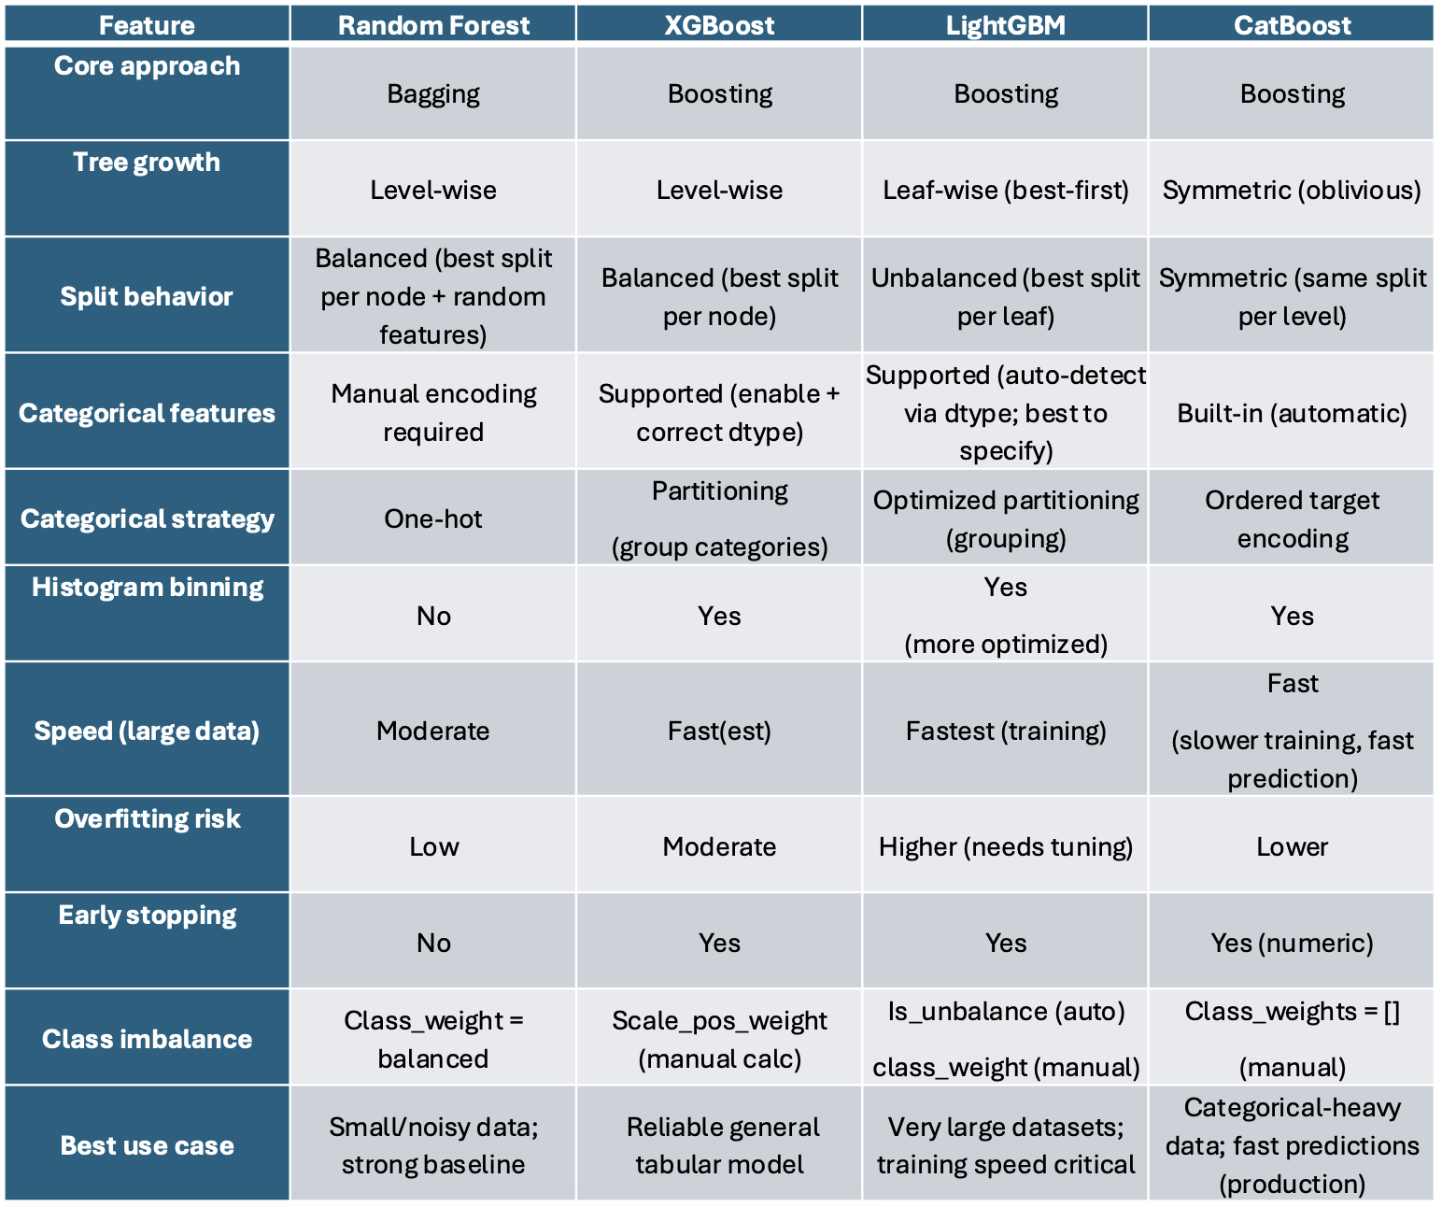

Tuning with Optuna
